Lab Plan – 5: Flutter ListView, ListTile, SnackBar and Cards

Task 1: Create a Flutter Project
- Open VS Code or Android Studio.
- Use shortcut:
Ctrl + Shift + P → Flutter: New Project (for VS Code).
- Name your project lab_plan_5 and set up the folder location.

Task 2: Add an AppBar with Centered Text
- Create a Stateless Widget using shortcut stle.
- Inside Scaffold, add an AppBar.
- Use centerTitle: true to align the text in the center.
- Add font size, font weight, and style to the AppBar title.

Task 3: Display Items with ListView and ListTile
- Use a ListView widget in the body of Scaffold.
- Each item should be displayed using a ListTile widget.
- The title of ListTile should be the name of the item.

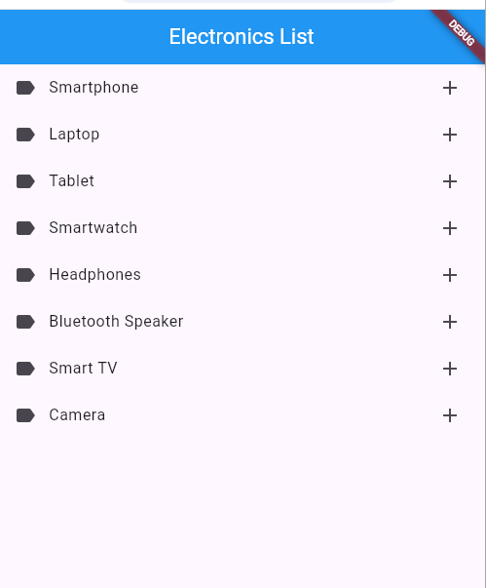

Task 4: Create a List of Items (Choose icons of your choice)
  - Smartphone
  - Laptop
  - Tablet
  - Smartwatch
  - Headphones
  - Desktop Computer
  - Wireless Earbuds
  - Gaming Console
  - Smart TV
  - Bluetooth Speaker
  - Power Bank
  - Portable Hard Drive
  - Drone
  - Digital Camera
  - Keyboard
  - Mouse

Note: if you want to create a snackbar in the same widget then use a Builder class
Scaffold(
body: Builder(
builder: (context) => ListView(
children: [
ListTile(
onTap: () {
ScaffoldMessenger.of(context).showSnackBar(...);
},
),
],
),
),
);

Task 5: Add SnackBar
- Use the onTap property of ListTile.
- When a user taps an item, display a SnackBar at the bottom.
- The SnackBar should show a message like:
"Tapped on Smartphone"
- The item name should change dynamically depending on which item is tapped.

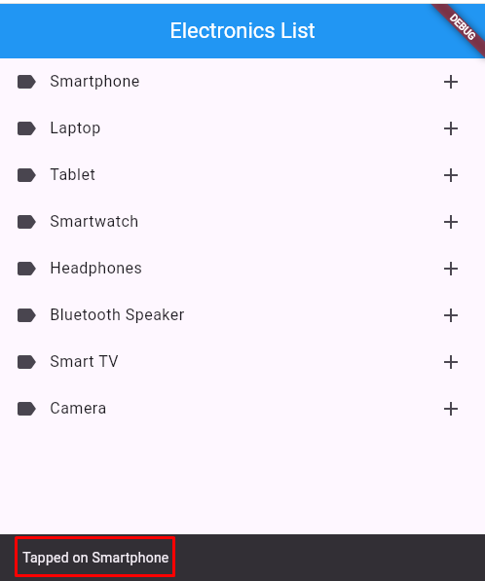

Task 6: Create Flutter Cards
Create a Flutter app that displays a list of electronic products using Card widgets.
Each card should show:
- An icon or image
- The product name
- A short description
- A price tag
